Moving down the list of apps to update, Advanced Advanced Find is up next. I’m a bit surprised. The app really doesn’t do much despite the name. I intended it more as a code sample. But if you guys want it, you got it. Here is the 2013 version of Advanced Advanced Find.
If you are not familiar with the app, it’s a simplified version of the Advanced Find feature, but it allows for OR style searches. The Must rule is the default AND behavior. The May rule gives you OR style behavior.
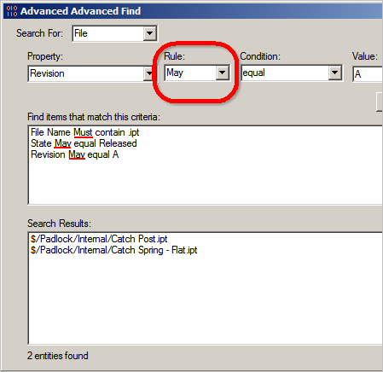
Again, I didn’t have much time to update things. I added support for Folder and Custom Object searches, but that’s it.
Requirements:
Vault Workgroup/Collaboration/Professional 2011
Click here to download the application
Click here to download the source code
Click here for the 2011 version. Sorry, there is no 2012 version.

